Ex. No. 1 | Usecase Diagram
Date of Exercise | 10-01-2017

Aim
To draw a Use case diagram for on-line railway reservation.
Video : https://youtu.be/V4c8qm7m7YY
Description
Use case diagrams identify the functionality provided by the system (use cases), the users who interact with the system (actors), and the association between the users and the functionality. Use cases are used in the Analysis phase of software development to articulate the high level requirements of the system. The primary goals of Use case diagrams include:
- Providing a high-level view of what the system does.
- Identifying the users (actors) of the system.
- Determining areas needing human-computer interfaces.
Use cases extend beyond pictorial diagrams. In fact, text-based use case descriptions are often used to supplement diagrams, and explore use case functionality in detail.
The basic components of Use case diagrams are the Actor, the Use case and the Association.

Actor
An Actor, as mentioned, is a user of the system, and is depicted using a stick figure. The role of the user is written beneath the icon. Actors are not limited to users. If a system communicates with another application and expects input or delivers output then that application can also be considered an actor.
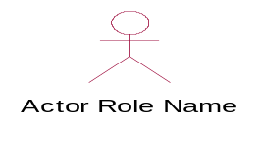

Use Case
A Use Case is functionality provided by the system, typically described as verb + object (eg: Register Car, Delete User). Use cases are depicted with an ellipse. The name of the use case is written within the ellipse.
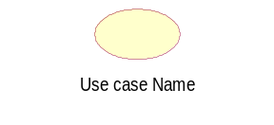

Association
Associations are used to link Actors with Use cases, and indicate that an Actor participates in the Use case in some form. A line connecting the Actor and Use case depicts associations.

The following image shows how these three basic elements work together to form a use case diagram.
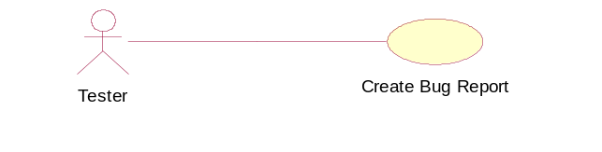
<<include>>
Use case include is a directed relationship between two use cases which is used to show that behavior of the included use case (the addition) is inserted into the behavior of the including (the base) use case.
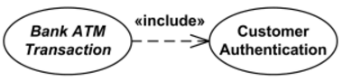
<<extend>>
Extend is a directed relationship that specifies how and when the behavior defined in usually supplementary (optional) extending use case can be inserted into the behavior defined in the extended use case.
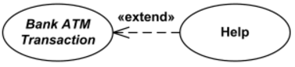
Include relation-ship is mandatory and extend is an optional.

Scenario of the application
The user can login into the railway reservation system using authorized password and username. The system then allows the user to use the services provided by the railway reservation server. When user is booking the ticket the user have to enter the destination and the amount to be paid is calculated by the server and prompted to the user. User then uses the bank account server to pay the amount and confirm the ticket.
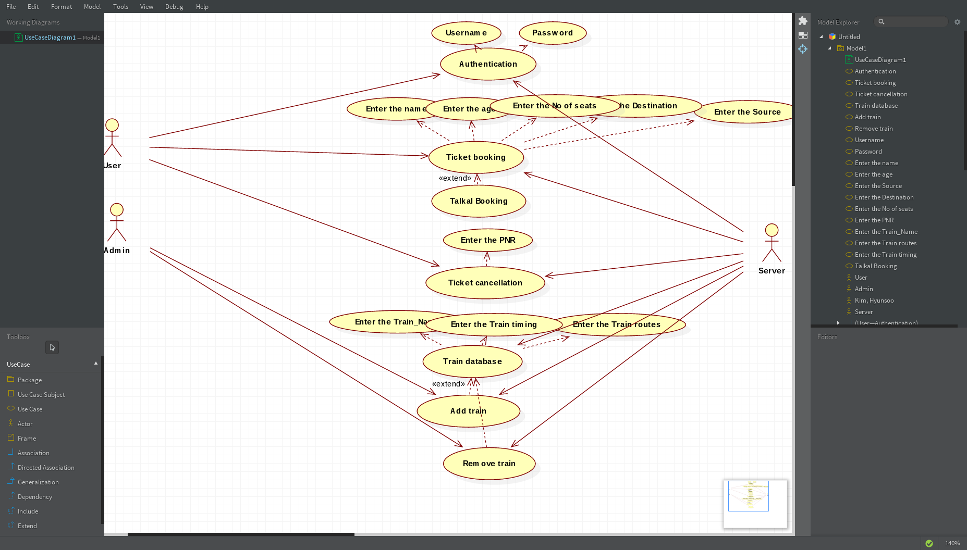
Usecase Diagram for the application
Functionalities of the usecases used
Usecase name | Explanation
Check Ticket Availability  Pay fare amount  Book ticket  Fill out personal details  Cancel ticket  Refund money | Used to check ticket availability from the railway database  Traveller pays the amount and saves it in the database  After paying the amount,the traveler shall be able to book the ticket.Hence use case of pay fare amount is included in book ticket  The traveler fills out the personal details after choosing the option of booking ticket  Used to cancel the ticket and the database is updated  Used to refund money and updated in the database

Result
The usecase diagram for on-line railway reservation is completed and verified.

